Deep Gratitude
October 18, 2026
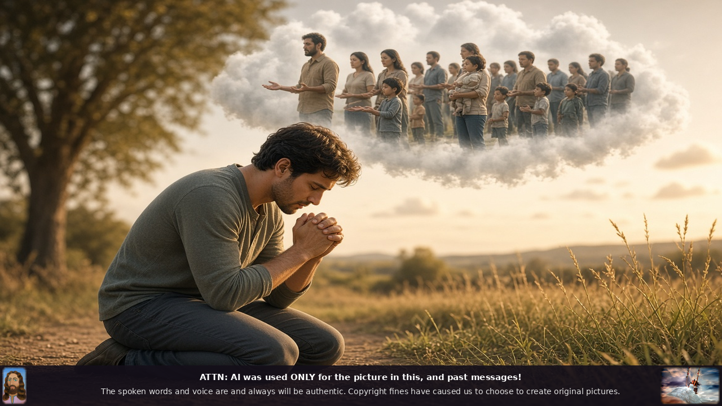
The Lord Jesus bless and keep you dear family with a full and thankful heart. I am writing to express our deep gratitude for the generous support you've given over the years. Your kindness has made a real and lasting difference for the people we serve who are quite impoverished because of you.
We've been been able to walk alongside individuals and children and families for many years, providing clothing, heat, and food, and helping them through difficult seasons and reminding them that they are not alone and that Jesus loves them.
We find ourselves in a challenging time.
Dear ones, donations have been lower than usual and as a result we are currently unable to send out the funds to some of our orphanages and rescue houses for trafficked women and children that we've been supporting for years. This is heartbreaking for us.
These are not new relationships; they are people we know and care about deeply and the thought of not being able to continue that support weighs heavily on our hearts.
One immediate need has come due and that's our firewood bill. This wood is for the people we serve 25 to 30 families, and we pass it out on a rotating basis to keep their homes warm as the colder months arrive. They are currently burning sagebrush for heat. We are not able to pay it right now and that weighs on us as we want them to be safe and comfortable. At the same time, we want you to know that we are being especially careful with every resource entrusted to us.
We are spending less in-house than we ever have, so that as much as possible can go directly to those who need it. We are doing everything we can on our end, but we cannot do it alone.
If you are able to help again at this time, whether with a one-time gift or by increasing your regular support, it would mean the world to us and to the people who depend on this help. We understand that times can be difficult for everyone and we're grateful for whatever you are able to give. Even more we are grateful for the partnership and love you have already shown to us by being so faithful.
Thank you for standing with us. Your generosity has already changed many, many lives, and any further help you can offer will allow us to keep walking with those we have promised not to forget, and to meet practical needs like keeping homes warm. Thank you.
My precious ones.
Please remember to pray for us and pray for our donors that the enemy hasn't in some way affected their ability to donate. Pray that any assignments will be broken over finances.
And just a note that I wanted to mention, and that is that we use AI only for painting pictures and putting together pictures that will reflect the message in the videos. Everything else is recorded live just for you.
One other thing I wanted to mention, and a bookkeeper caught on to me about this, is make checks payable to Heartdwellers, not personally to Clare duBois, just for the sake of keeping the government properly informed.
So, we thank you Lord, in advance, because you always hear the cry of the poor.
Amen.

